QUESTION LINK: <https://www.hackerrank.com/challenges/revising-the-select-query/problem?isFullScreen=true>

Query all columns for all American cities in the **CITY** table with populations larger than 100000. The **CountryCode** for America is USA.

The **CITY** table is described as follows:

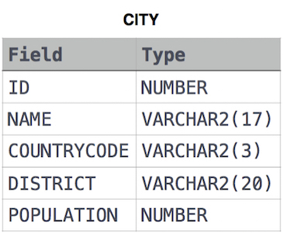

***SOLUTION:***

SELECT *

FROM CITY

WHERE POPULATION > 100000 AND COUNTRYCODE LIKE 'USA'